11.21: a) 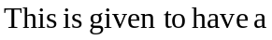 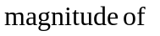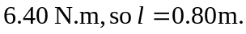 b) The net torque is clockwise, either by considering the figure or noting the torque found in part (a) was negative. c) About the point of contact of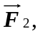the torque due to 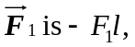 and setting the magnitude of this torque to 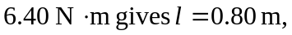 and the direction is again clockwise.

